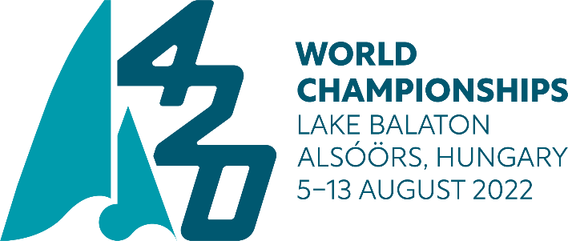

SUPPORT BOAT REGISTRATION FORM
FOR OBTAINING A LAKE BALATON TEMPORARY PERMIT

In case your team is arriving with a support boat to the Worlds, and it is not registered in Hungary, please fill in this form and send it in a signed format - together with the copy of the boat certificate - to the following e-mail addresses: balatoniyachtclub@gmail.com & 420worlds@balatoniyachtclub.hu

The support boat registration fee is 125 EUR, which shall be paid in EUROS to the International 420 Class bank account:

Account Header: International 420 Class Association
Account No: 210 0467 180 80
Bank address: BNP Paribas Fortis Nieuwpoort-Centrum, Langestraat 56, B-8620Nieuwpoort, BELGIUM
IBAN: BE47 2100 4671 8080; SWIFT CODE: GEBABEBB

Deadline: July 8, 2022.

Please note, that after the deadline, OA and I420Class will not take responsibility for missing permits, or difficulties in obtaining the permits from the Lake Authority.

Country of origin
Registration certificate number of the support boat
Owner/Operator of the support boat
Manufacturer/Type of the boat
Serial number of the boat
Engine manufacturer
Serial no of the engine
Driver of the support boat during the event
Name
E-mail address
Mobile/cellphone no
Any comment
Attachment: Boat certificate

Signature of the team leader or coach

